**Quick Start Finance - Programming Journal**

**25JAN23: First Entry - Project Proposal**

**Link to Project Proposal document:** [Capstone Project Proposal](https://docs.google.com/document/d/106bV6xiJ_oVQ74e4kXi6avEoCzRkrBR6fxIfPzwysi4/edit?usp=sharing)

**Application title: Quick Start Finance** – ***A “Younger” Personal Finance Application***

**Purpose**: The purpose of the Quick Start Finance application is to enable young users to track their personal budgets of income and expense in an easy-to-read, simple, light-weight manner.

**Program procedures**: The Quick Start Finance application will enable users to create a personal account. The personal account will include username, birthday, phone, address and password. Then the user may login into a dashboard. Within the personal dashboard, the user will then be able to enter individual income records, including income title/name, categories, date of income, income amount and description of the income record. Likewise, the user will be able to enter the same details for expenses. There will be a navigation menu that will allow the user to easily view the dashboard, income page, expense page, as well as tabs to view income/expense records and totals, and finally to logout.

**Target Client**: This application is mainly targeted toward young, college age individuals who want to get started tracking their money without too much complication or confusing financial numbers (things that may be important later in life). It will enable teenagers and early twenty-somethings to gain some financial literacy and understand the arithmetic of incoming money and outflowing expenditures to help prepare for getting on their own, before their personal “checkbooks” and financial statements become too complicated.

**Notes and restrictions**: This application may be of use to older users for the simple transactions mentioned above. However, it has limited application and would not be a good fit for someone with complex needs, such as investments, retirement, taxes or asset reporting. The user will not see income statements or balance sheets. Indeed, mature users may find the interface even childish or naïve. Again, we are specifically targeting the youth.

**Comments**: Our hope at the Quick Start Finance Company is to urge young people to begin taking stock of their financial situation and ease them into a life of financial literacy.

**26JAN23: Second Entry - Project Proposal Presentation**

**Link to Project Proposal Presentation:** [Quick Start Finance - Project Presentation](https://docs.google.com/presentation/d/1oxM4Nl0Wy-VjRvQ3P1Fmfw_QTj7ak6STuHAaKPWx6TY/edit?usp=sharing)

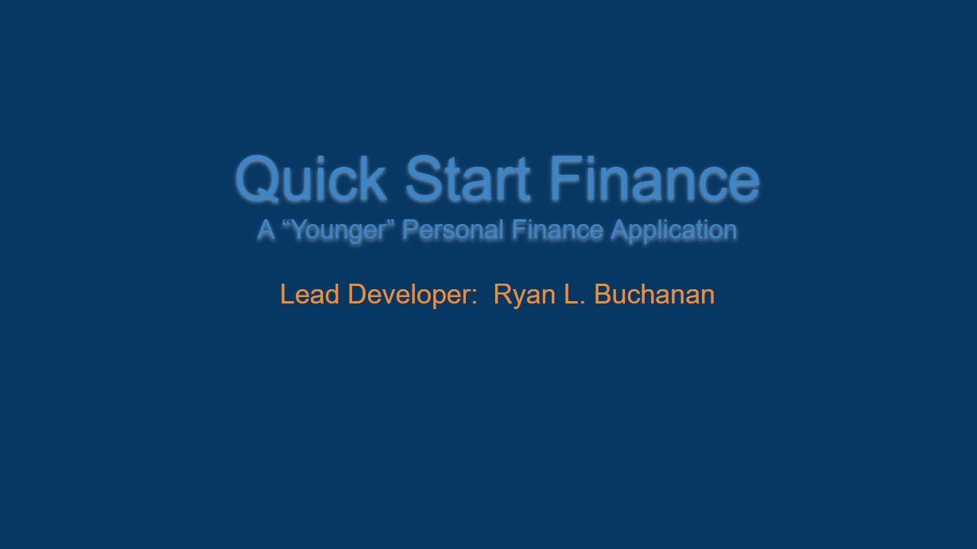

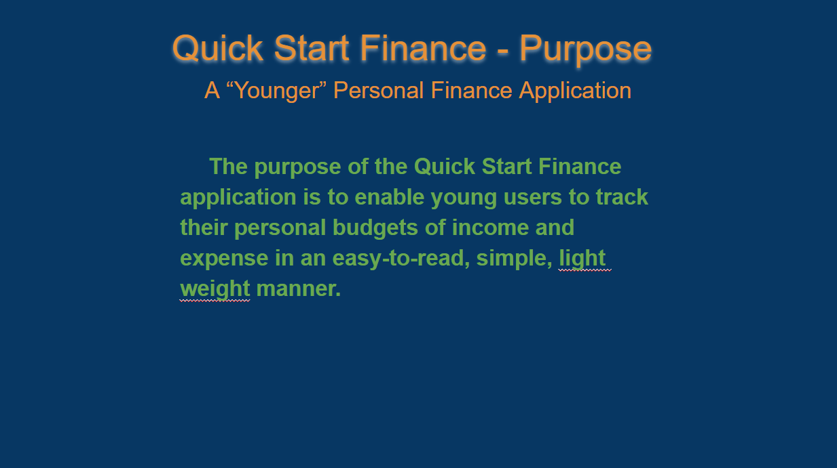

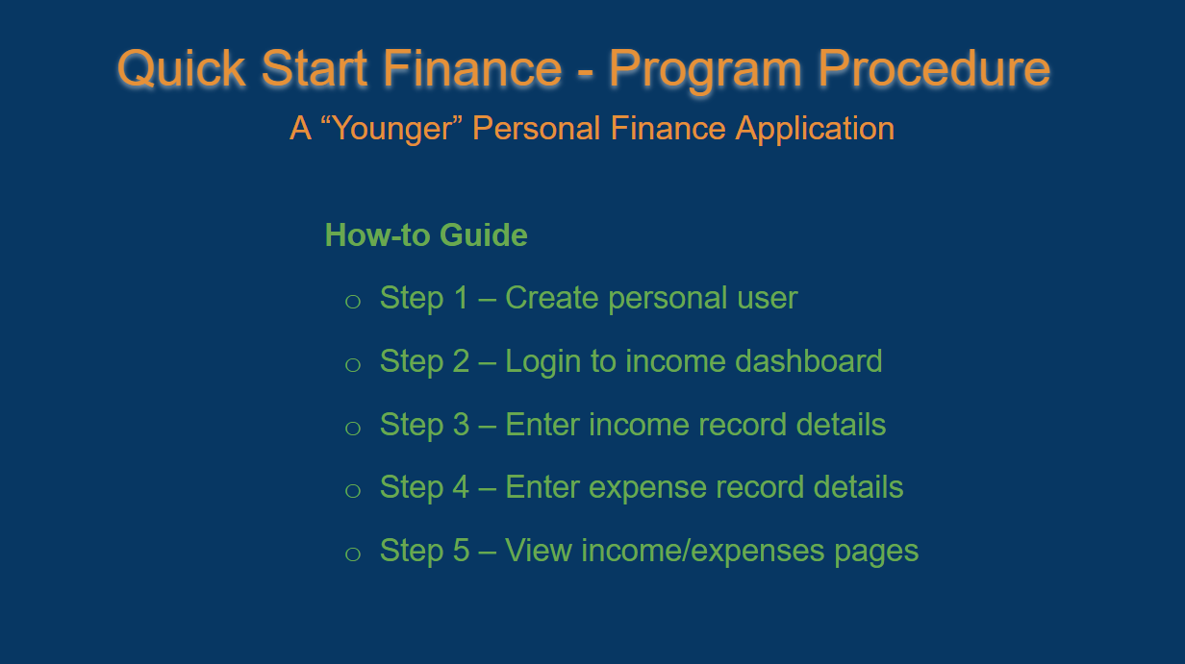

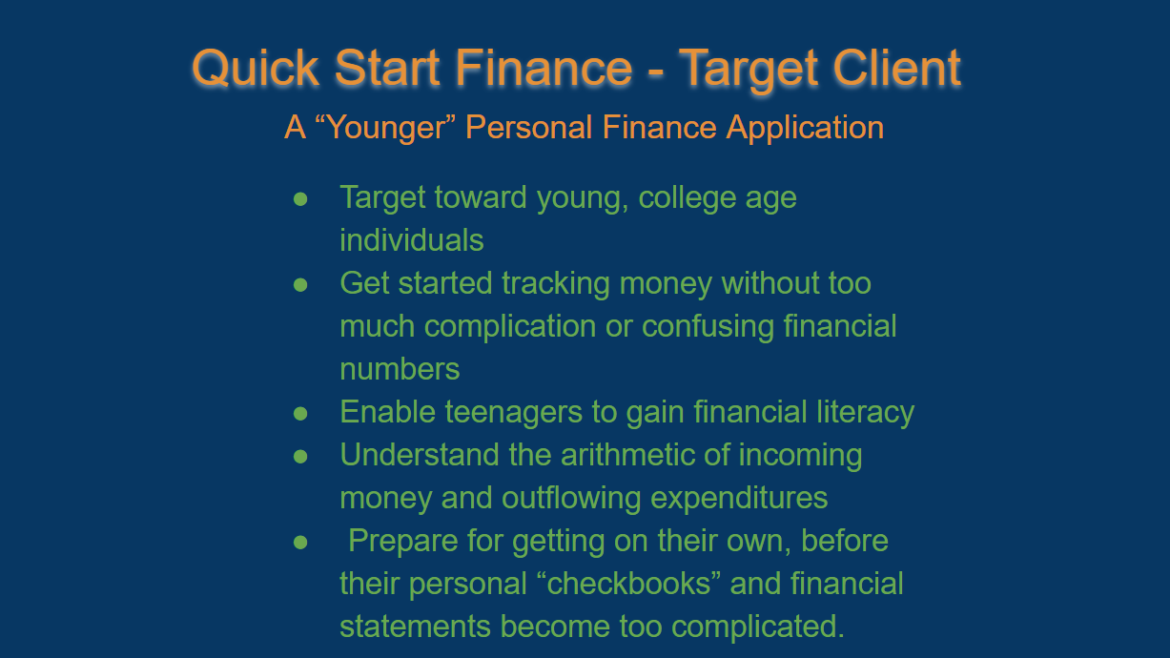

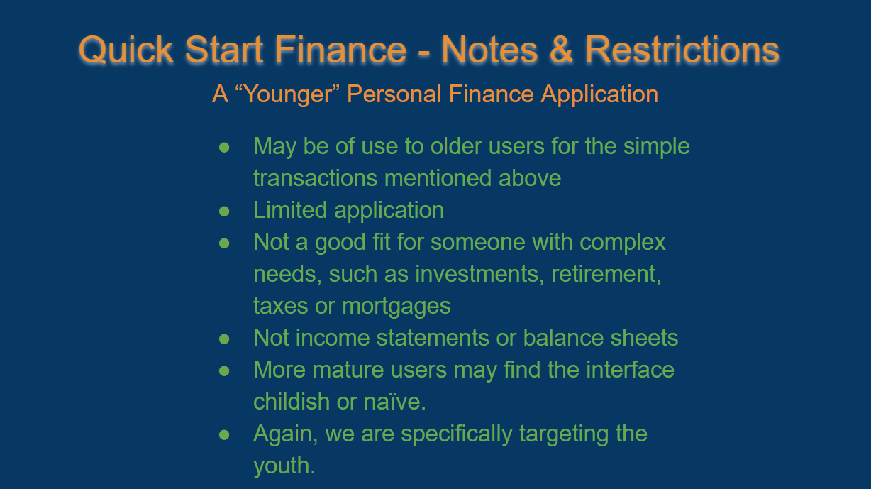

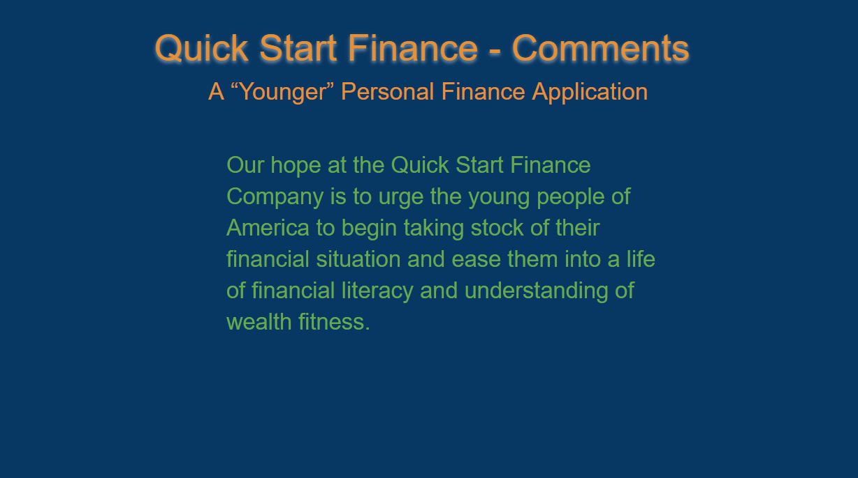

**27JAN23: Third Entry - Wireframing and Initial GUI Prototype Sketches**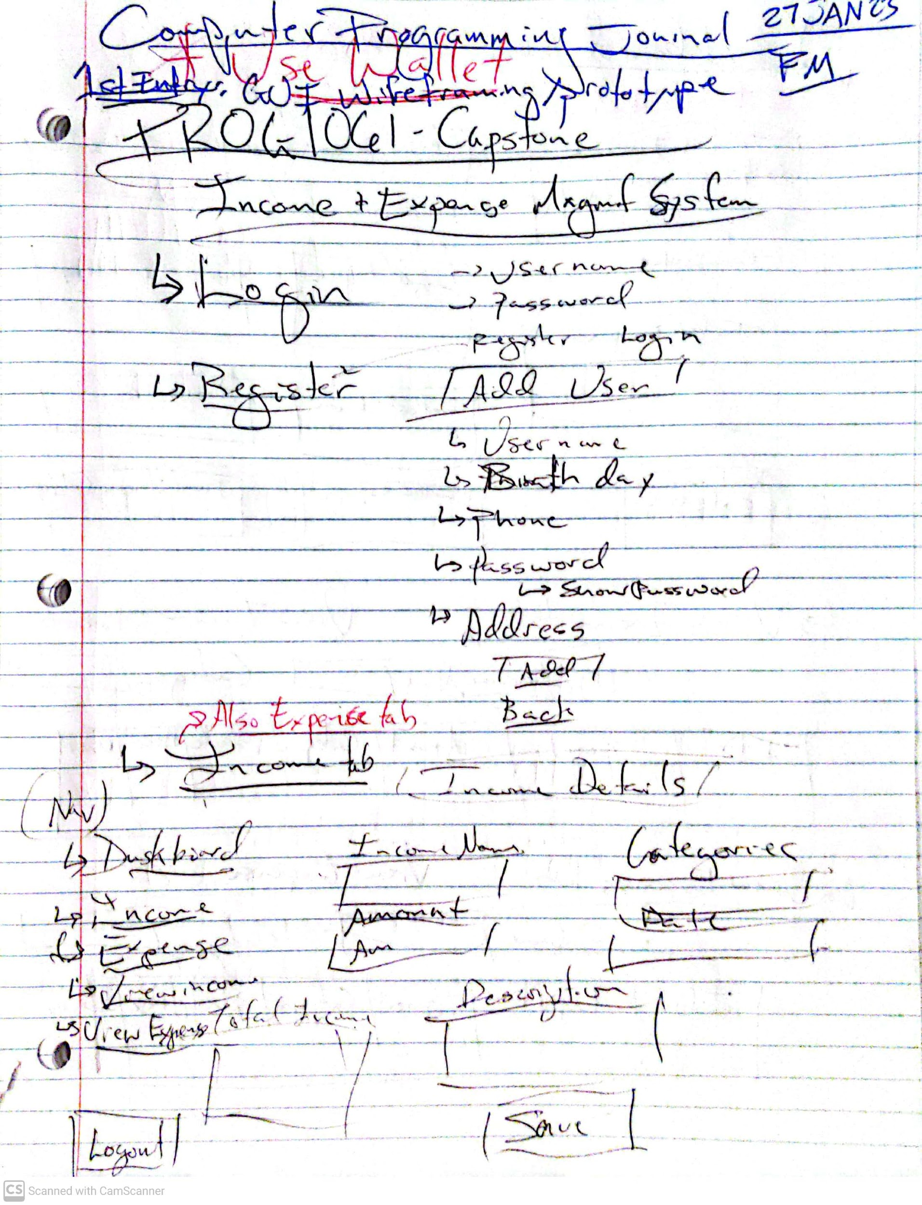

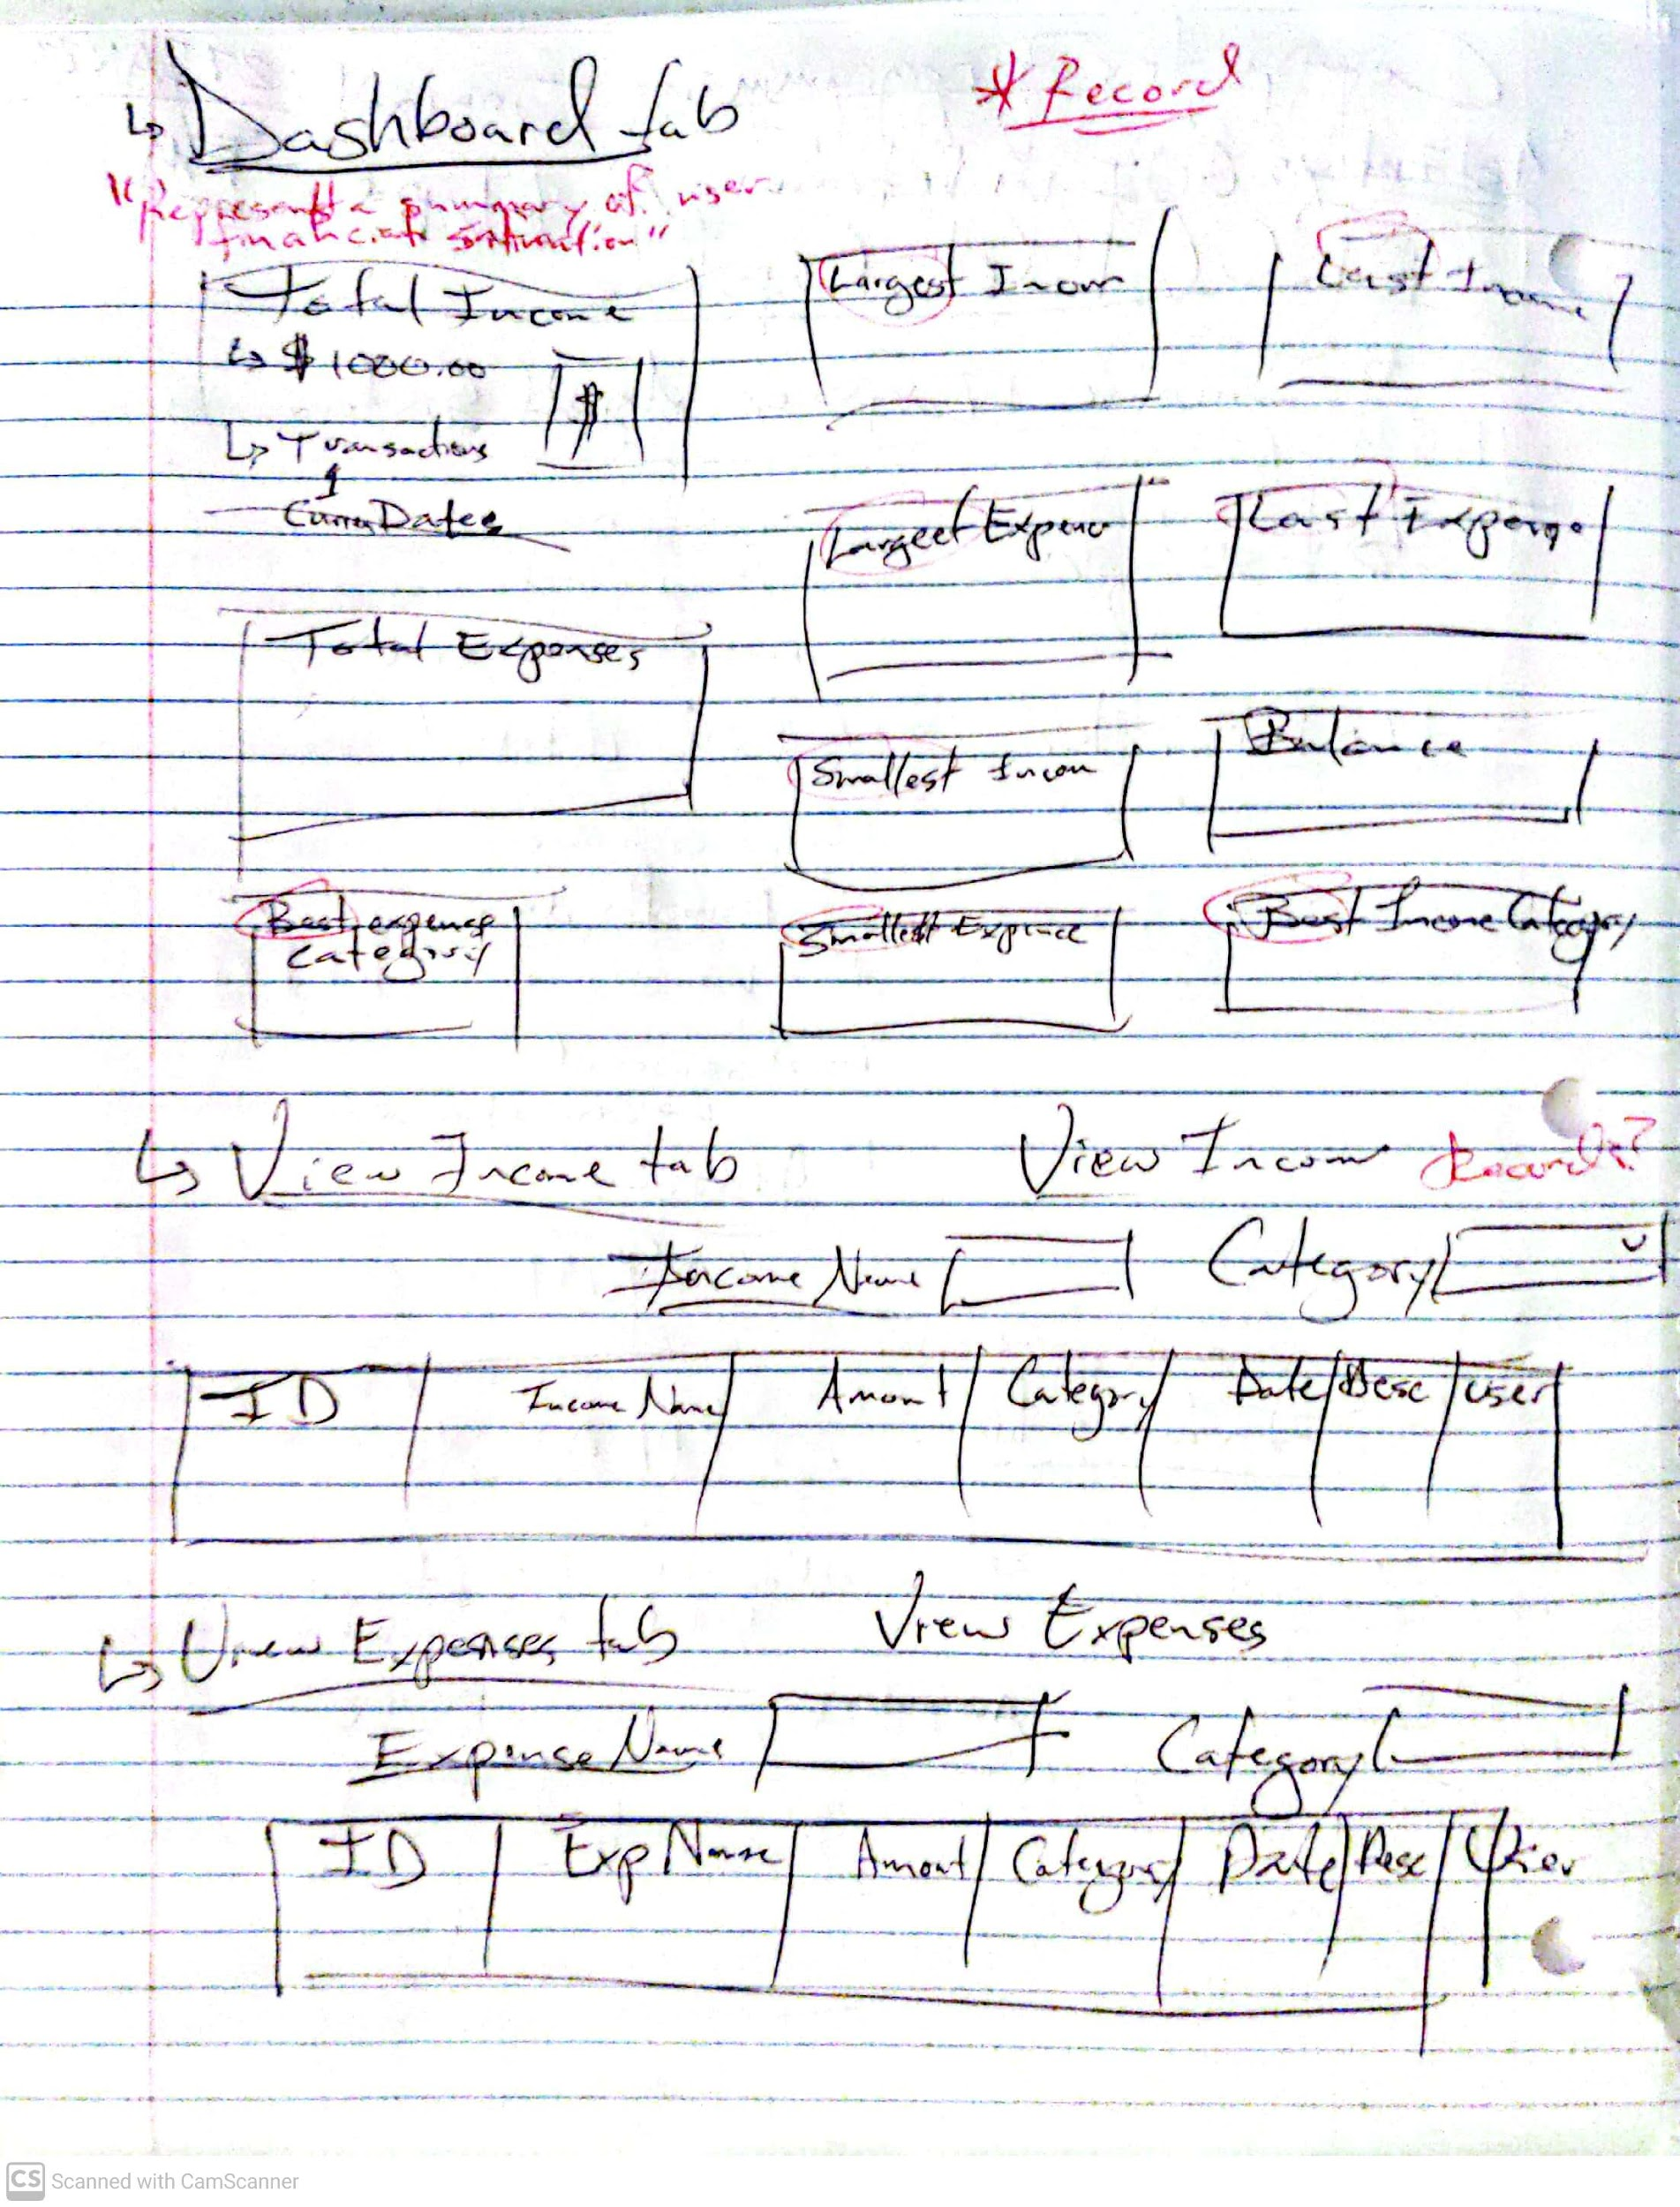

**28JAN23: Fourth Entry - Github repository - “Quick_Start_Finance”**

**Link to Github repository:** [**https://github.com/RyanLBuchanan/Quick_Start_Finance**](https://github.com/RyanLBuchanan/Quick_Start_Finance)

**28JAN23: Fifth Entry - Trello Board - “Quick Start Finance”**

**Link to Trello board:** [**https://trello.com/invite/b/2RBNMqV2/ATTI81e07296f9dc3ad7cc89dd029d0a029b2DDAFDEA/quick-start-finance**](https://trello.com/invite/b/2RBNMqV2/ATTI81e07296f9dc3ad7cc89dd029d0a029b2DDAFDEA/quick-start-finance)

A great start! Project feels fully initiated.

**28JAN23: Sixth Entry - Module 2: Deliverable I**

Deliverable I includes:

1. Trello board “Quick Start Finance link: <https://trello.com/invite/b/2RBNMqV2/ATTI81e07296f9dc3ad7cc89dd029d0a029b2DDAFDEA/quick-start-finance>
2. Github “Quick_Start_Finance” repository link: <https://github.com/RyanLBuchanan/Quick_Start_Finance>
3. Zipped folder containing:
   1. Visual Studio beginning of “Quick_Start_Finance”
   2. Dashboard Winforms form and C# script
4. Quick Start Finance Login and Dashboard wireframes (below):